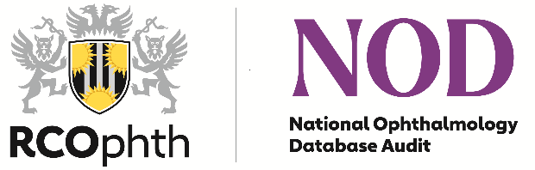
National Ophthalmology audit Database (NOD)
New Joiners Form

Please tick the relevant box to indicate which audits the organisation will contribute to:
National Cataract Surgery Audit ☐
National wet-Age-related Macular Degeneration Audit ☐

Before completing this form, please consider contacting the NOD team to discuss your current situation and requirements.

NOD is recognised by clinicians, NICE, GIRFT and industry as an important safety and research tool that can also be used to audit the treatment of both common and potentially blinding diseases such as cataract and age-related macular degeneration.

NOD audits aim to provide real-world benchmarks and enable patients, providers and commissioners to compare clinical outcomes and key care processes at different sites, enabling informed decision-making and patient choice.

The cataract audit is recognised as an exemplar large-scale audit delivering system transformation that improves the quality and safety of patient care, and reducing unwarranted variation. The newly launched AMD audit provides a platform for prompt diagnosis of AMD to enable continued maintenance treatments that are vital to maintaining vision, informed decision-making and patient choice.

We welcome participating sites to submit clinical data, collected as part of routine clinical care, to NOD for analysis.

Participation in both audits is open to both public and independent providers, across England, Scotland, Wales, Northern Ireland and the Channel Islands.

Please complete and return this form by email to noa.project@rcophth.ac.uk

Organisation details – please print clearly

Organisation name
Organisation ODS code (England only)
Main contact name
Role
Contact Details (email and telephone)
Full address and postcode
Additional contact details:
Contact Details - Medical Director/Caldicott Guardian (first name/surname; email)
Contact Details – Clinical Lead (first name/surname; email) - please specify details if different for each audit
Contact Details for sending invoice/purchase orders (email and telephone)
Name/Role (first name/surname)

Data collection method | ☐ Electronic Medical Records (EMR)  ☐ In-house data collection template  ☐ Other (please specify)
EMR provider
EMR version number (if applicable)
Status | ☐ NHS  ☐ NHS/Private  ☐ Solely Private Provider  ☐ Independent Sector Treatment Centre (ISTC)
Number of your sites interested in participating
Cataract: approximate number of cataract operations performed annually across all sites (minimum requirement 200 per year)
AMD: approximate number of eyes starting treatment each year
(we aim for 50 eligible each year as of 2023)
Specify percentages for provision of both NHS funded and non-NHS funded cataract surgery (if applicable)
Are you compliant with the Minimum Cataract National Dataset? (please refer to the NOD audit website: https://www.nodaudit.org.uk/resources/guides)
Are you compliant with the AMD Audit Clinical National Dataset? (please refer to the NOD audit website: https://www.nodaudit.org.uk/resources/guides)
Identify potential issues around data collection and submission
Readiness to join the audit:  Audit data is currently collected from 01 April to 31 March over a 12-month period for both audits, aligned with NHS reporting years.  The next data extraction for 2021/2022 data will provisionally take place April/May 2023 with the results published later | ☐ Intending to join for this data extraction  NOTE: - if you do not have data for the full period we will still accept a partial submission as long as it covers the minimum number of operations (200). We can make appropriate adjustments as part of the data analysis
Data collection and submission note:
The usual route for data submissions if for units with existing EMR to submit data collected electronically, compliant with the Minimum Cataract National Data Set or AMD Audit Clinical Data Set for the National Ophthalmology Database Audits
- Organisations with an existing EMR system or database will have their data extracted remotely from the EMR system (or liaise in-house with your IT department to arrange extractions – in accordance with EMR provision) and uploaded securely into the National Ophthalmology Database via the audit website.
- For organisations that do not have an EMR, please state your data collection method
- For organisations with paper-based records and no EMR the RCOphth can provide electronic data collection tools for the Cataract audit only to enable participation.
Further details are available by contacting the NOD audit team at: noa.project@rcophth.ac.uk
We wish to sign a Data Sharing Agreement with The Royal College of Ophthalmologists (a Purchase Order Request Form, for invoicing purposes, will be sent on receipt of a signed Data Sharing Agreement | ☐ Yes  ☐ No

For internal use only
DSA counter-signed / date
Joined the audit / date

